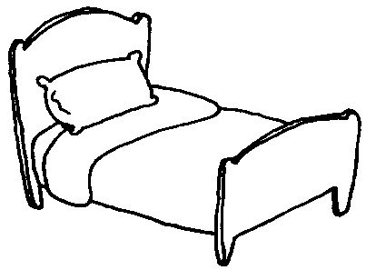

1. There is an Apple on the table.
2. There is an Orange on the desk
3. There is a Watermelon on the chair
4. There is an Avocado on the couch
5. There is a spider on the bed
6. There are two bananas on the couch
7. There are four ants on the desk
8. There are two pinneaples on the chair
9. There are two lemons on the table
10. There are three peas on the bed

